**CUTRIC BURLINGTON PROTOTYPE**

OCAD University Visual Analytics Lab

Sara Diamond, Jeremy Bowes, Mona Ghafouri-Azar, Grace Yuan

# Introduction

The *CUTRIC Transit Fleet Electrification Analysis – Burlington* prototype is a dynamic HTML dashboard visualization environment that supports all the analytics that CUTRIC undertook and even extends these. It provides a GIS map (Cartographic) interface and related graphs/charts. We use the city of Burlington as the use case to develop the porotype. However, the prototype should serve as a template that can be applied to any other CUTRIC cities.

Based on CUTRIC’s request, all the tools we used are open source and free to use. We decided to use Mapbox(<https://www.mapbox.com/>) for all the on-map visualization. For graphs and charts, we use the JavaScript library D3.js(<https://d3js.org/>), which comes with powerful resources for various types of data visualizations. The outcomes are a series of HTML web pages that can be hosted on CUTRIC’s servers.

Table of Contents

Introduction 1

Page Structure 4

1. Cities 4

2. Simulation Results 4

3. Charging Results 4

4. GHG Emissions Analysis 4

5. Electricity Cost Estimation 4

6. About 4

7. Contact 4

1. Landing Page/Cities 4

2. Simulation Results 6

3. Charging Results 9

4. GHG Emission Analysis 11

5. Electricity Cost Estimation 14

6. About 15

7. Contact Us 16

Code Components 17

Mapbox 17

D3.JS 17

Graphs hosted on Observable 17

Table of Figures

Figure 1 - The Landing page: A national map with all the CUTRIC cities 5

Figure 2 - The Landing page: Zoomed-in view of the city of Burlington 5

Figure 3 - The Simulation Results page 6

Figure 4 - Drop down menu 7

Figure 5 - Figure 9 in the Burlington report 7

Figure 6 - Figure 5 in the Burlington report 8

Figure 7 - Range Analysis – Weekday 8

Figure 8 - Range Analysis – Saturday and Sunday 8

Figure 9 - Success rate of one-to-one replacement of diesel buses with BEBs 8

Figure 10 - Interaction between the graph and the map 9

Figure 11 - The Charging Results Page 9

Figure 12 - The recovery time for Saturday vehicles graph 10

Figure 13 - The energy consumption graph 11

Figure 14 - A comparison chart of 2019 total GHG Emissions by diesel buses vs. BEBs 12

Figure 15 - Table 14 in the Burlington report 12

Figure 16 - 2019 Diesel usage by diesel buses at Burlington Transit 13

Figure 17 - Table 15 in the Burlington report 13

Figure 18 - Annual GHG emissions from electricity 14

Figure 19 - Figure 28 from the Burlington report 14

Figure 20 - Monthly cost comparison between diesel buses and BEBs 15

Figure 21 - The About page 16

Figure 22 - The Contact page 16

# Page Structure

The Nav Menu consists of 7 items:

### 1. Cities

Also known as the landing page. This page will host a national map with all the CUTRIC cities for the viewer to choose from. Viewer can always go back to the landing page to explore a different city.

### 2. Simulation Results

This page will host all the on-map visualizations with simulation results for range analysis.

### 3. Charging Results

This page will host all the standalone graphs related to charging, recovery time, and energy consumption by charging.

### 4. GHG Emissions Analysis

This page will host any standalone graphs related to the GHG emission analysis.

### 5. Electricity Cost Estimation

This page will host any standalone graphs related to the transit cost.

### 6. About

This is where CUTRIC introduce any information regarding this project or the team.

### 7. Contact

This page will host any contact information.

## 1. Landing Page/Cities

The prototype begins with a landing page to welcome the viewer. On the landing page there is a map for viewer to browse all the CUTRIC cities on the national level and select one city to review, by choosing one city name either on the side bar or on the map directly.

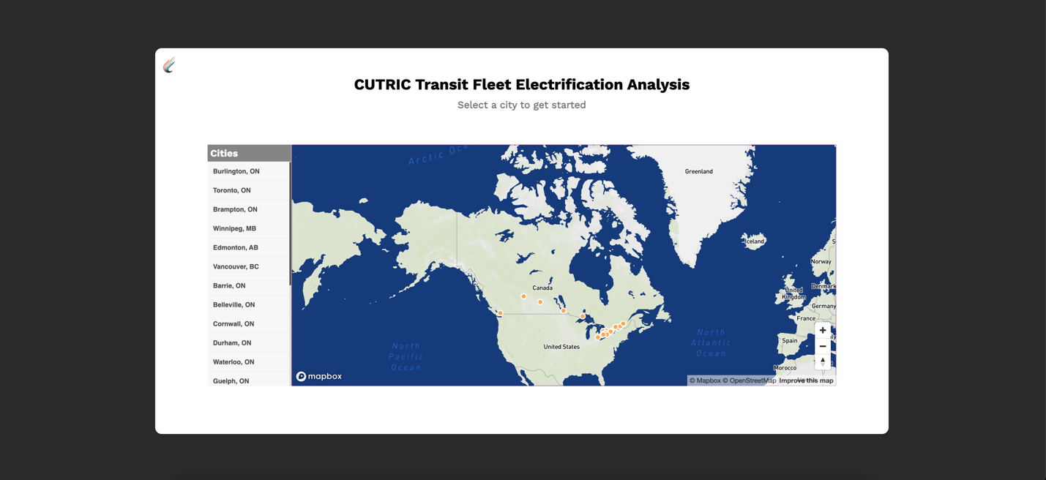

Figure 1 - The Landing page: A national map with all the CUTRIC cities

Originally centred around Canada, the map will fly to and zoom in between different cities based on the viewer’s selection. Once the viewer selects a city, the map flies to the city’s location and zoom in to the city’s level. An orange ‘Enter’ button shows up and when the viewer hover over it, the city’s name pops up in the tooltip. After confirming the city that they want to continue with and click on the ‘Enter’ button, the viewer will be taken to another webpage where they can find all the analytics and visualizations of that city. Each city will be hosted on a separate site/dashboard, for the ease of data organization and viewer navigation. For this prototype, viewer can only enter Burlington.

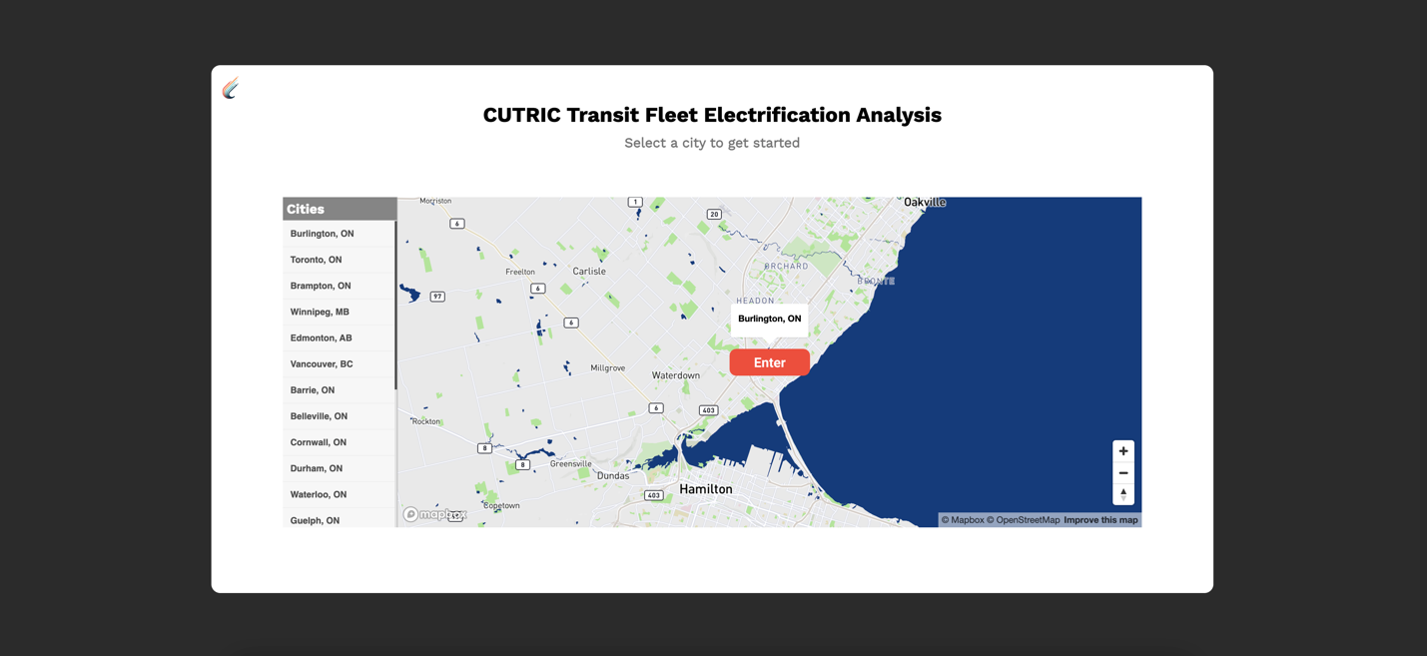

Figure 2 - The Landing page: Zoomed-in view of the city of Burlington

## 2. Simulation Results

All the map-related visualizations will live on this page. The top half of the screen consists of two maps for comparing two types of electric bus: the map on the left visualizes Bus #1(Battery 400+ kWh, Weight ~15,000 kg), and the map on the right visualizes Bus #2(Battery 600+ kWh, Weight ~ 15,000 kg). Basic map navigation controls are added to the map, including geocoder search bar, zoom in/zoom out, and reset bearing to north. On the left side of each map there are menus to toggle on and off map layers, including: 1) terrains/contours; 2) all the bus routes in Burlington; 3) all the bus stops. On the map, viewer can find the legends for all the potential electric bus charger locations with pop-up details on hover. On the right bottom corner of each map, there are two icons that will each take the viewer to the GHG Emissions Analysis page and the Electricity Cost Estimation page.

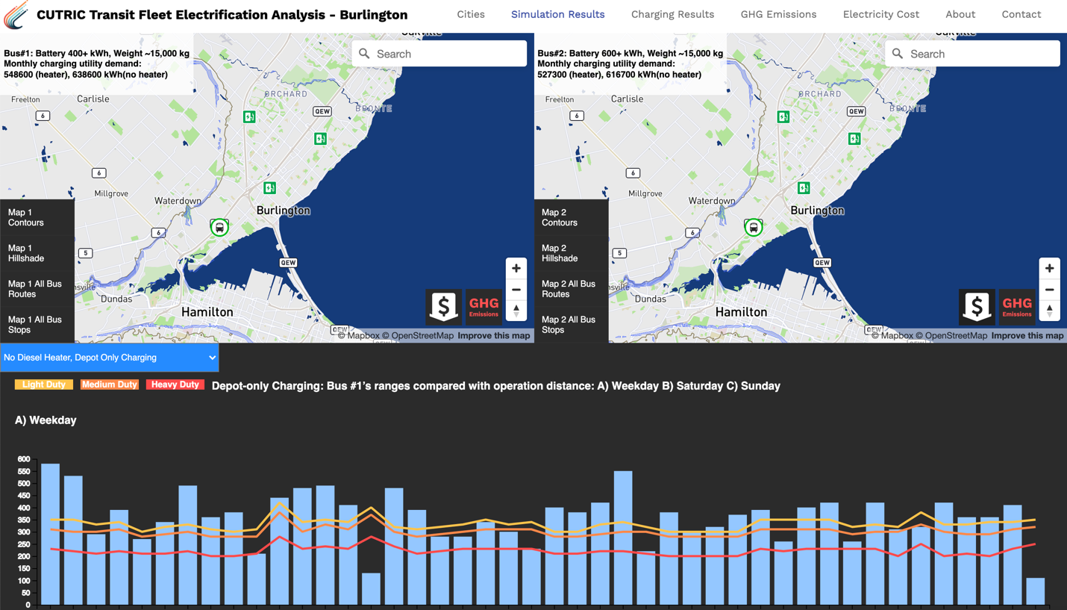

Figure 3 - The Simulation Results page

At the bottom half of the page, there is a drop-down menu to select between four sets of graphs: 1) No Diesel Heater, Depot Only Charging; 2) Diesel Heater, Depot Only Charging; 3) No Diesel Heater, Opportunity Charging; 4) Diesel Heater, Opportunity Charging. Each set of graph contains Range Analysis graphs for weekdays, Saturday, and Sunday; success rate of one-to-one replacement of diesel buses with BEBs.

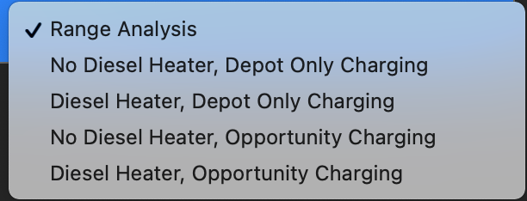

Figure 4 - Drop down menu

The range analysis graphs are built upon the graphs in the CUTRIC Burlington report. The data was roughly extracted from the graphs with non-accurate numbers because we were not supplied with the raw data. Please note that only one set of the range analysis graph was created based on “Figure 9. Bus #1’s ranges after using diesel heater compared with operation distance: A) Weekday B) Saturdays C) Sundays” and “Figure 5. Success rate of one-to-one replacement of diesel buses with BEBs without a diesel heater (summer and winter are the same)” from the report. We used this set of graphs repetitively under all four dropdowns to show how several graphs can be displayed to cover all four situations.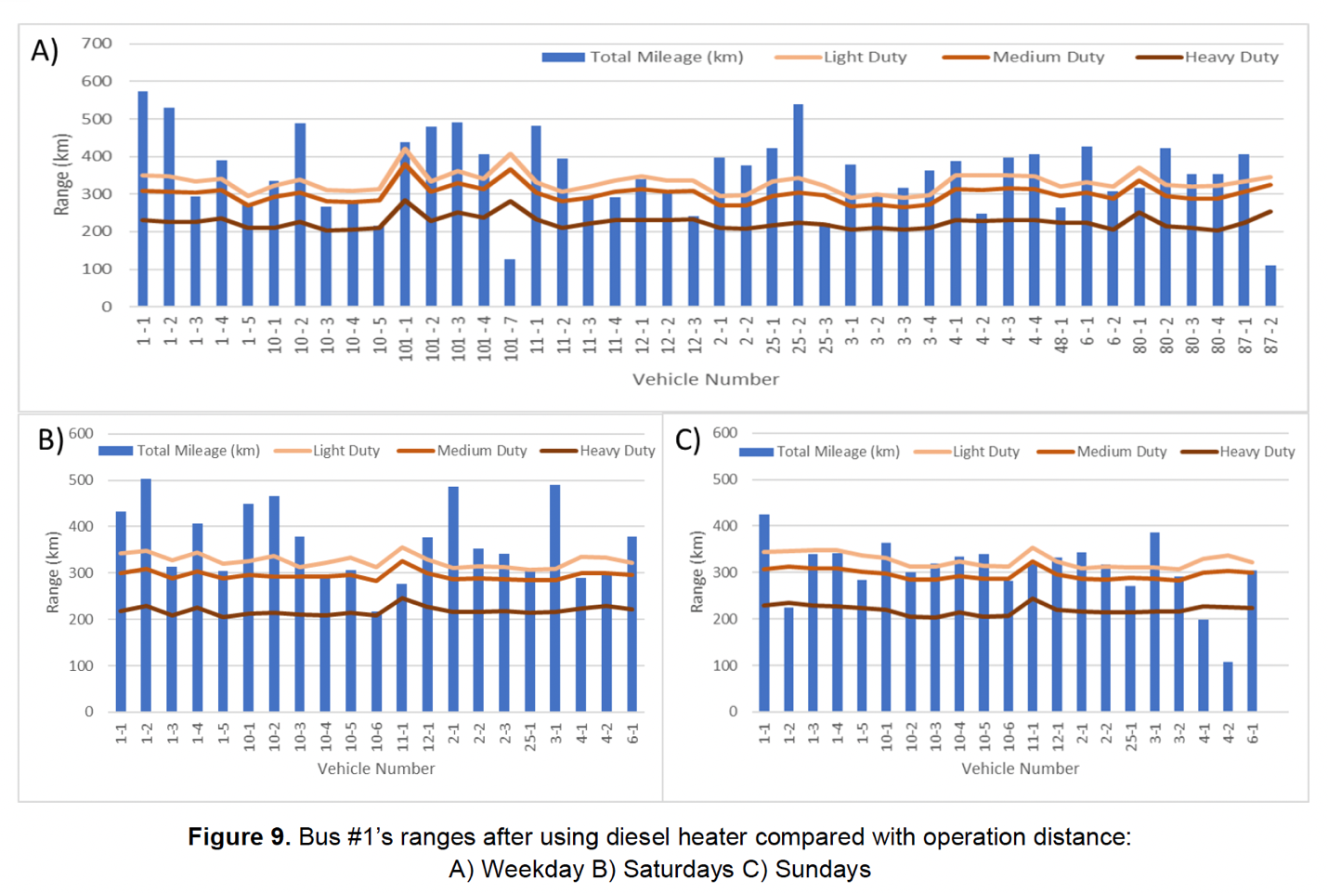

Figure 5 - Figure 9 in the Burlington report

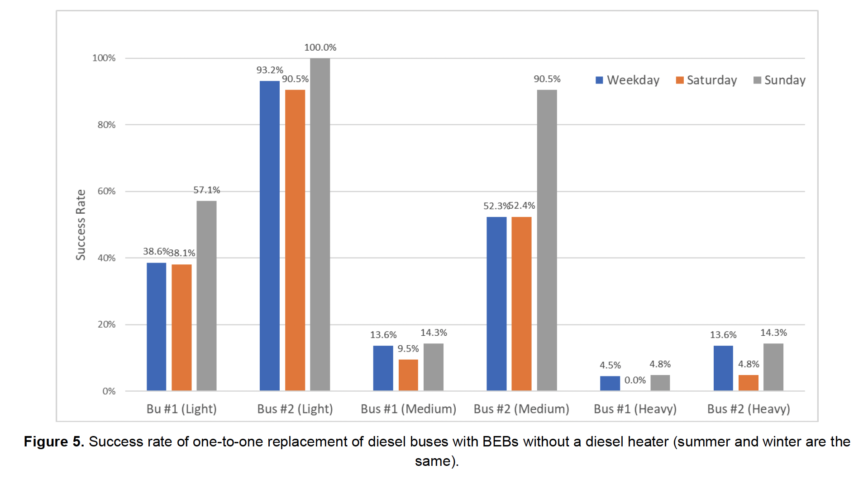

Figure 6 - Figure 5 in the Burlington report

When hover over each blue bar, more details will be displayed on a tooltip.

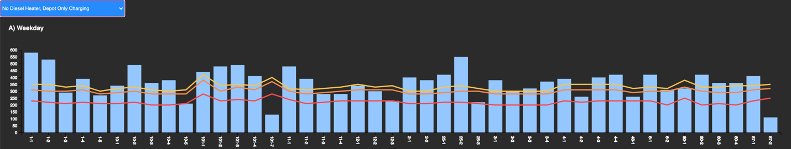

Figure 7 - Range Analysis – Weekday

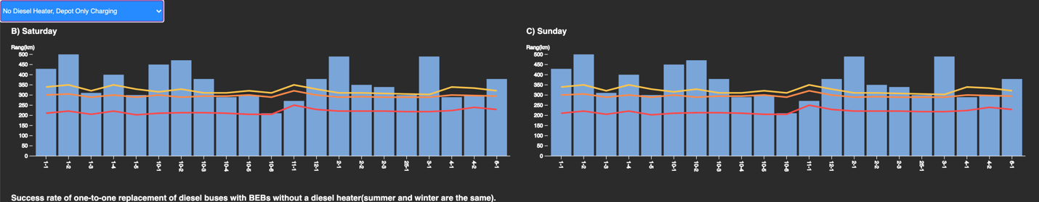

Figure 8 - Range Analysis – Saturday and Sunday

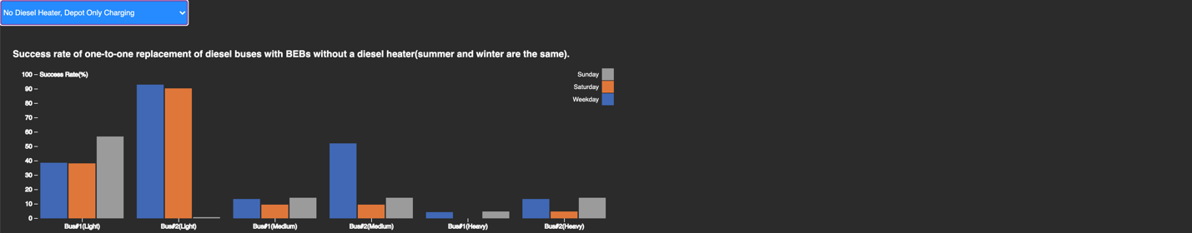

Figure 9 - Success rate of one-to-one replacement of diesel buses with BEBs

We implemented the interaction between the graphs and the maps by animating the bus running on route. Bus 1 and Bus 2 on route 4 are selected to be prototyped with animation. When the viewer clicks on the 4-1 or 4-2 blue bar on the Bus #1 graph, the corresponding bus will start running on the map. The outer circle of the bus icon represents the battery status of the bus.

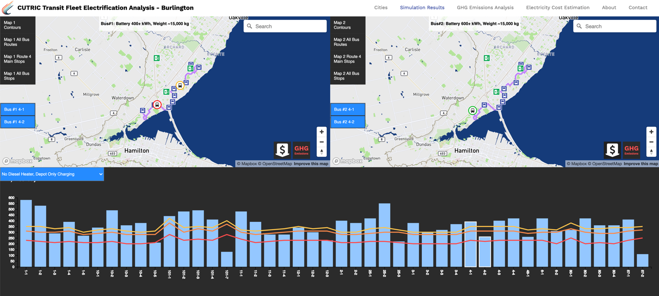

Figure 10 - Interaction between the graph and the map

## 3. Charging Results

On this page, the viewer will find 2 graphs related to the charging and energy consumption.

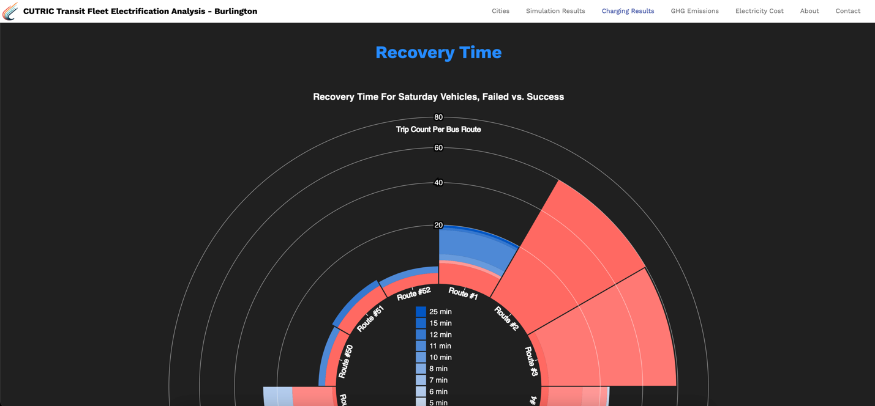

Figure 11 - The Charging Results Page

The first graph represents the failed and success proportion of the recovery time for Saturday vehicles. The required recovery time for opportunity charging is 5 minutes, thus, any trip with less than 5 minutes recovery time fails. For future development, Weekday and Sunday vehicles should be visualized as well.

For this graph, the X-axis shows the route numbers, while the Y-axis shows the count of trips on each route with corresponding recovery time. It aims to show among all the routes, which ones are already suitable for opportunity charging verses the ones that are not on a high level. The red gradient colors refer to the trips that do not meet the 5 minutes requirement, and the blue gradient colors refer to the success trips.

We took the “BT_RecoveryTime_Saturday” data and sorted out the trip counts based on recovery time and generated the data set “Recovery time Saturday.csv” that is used to create this graph.

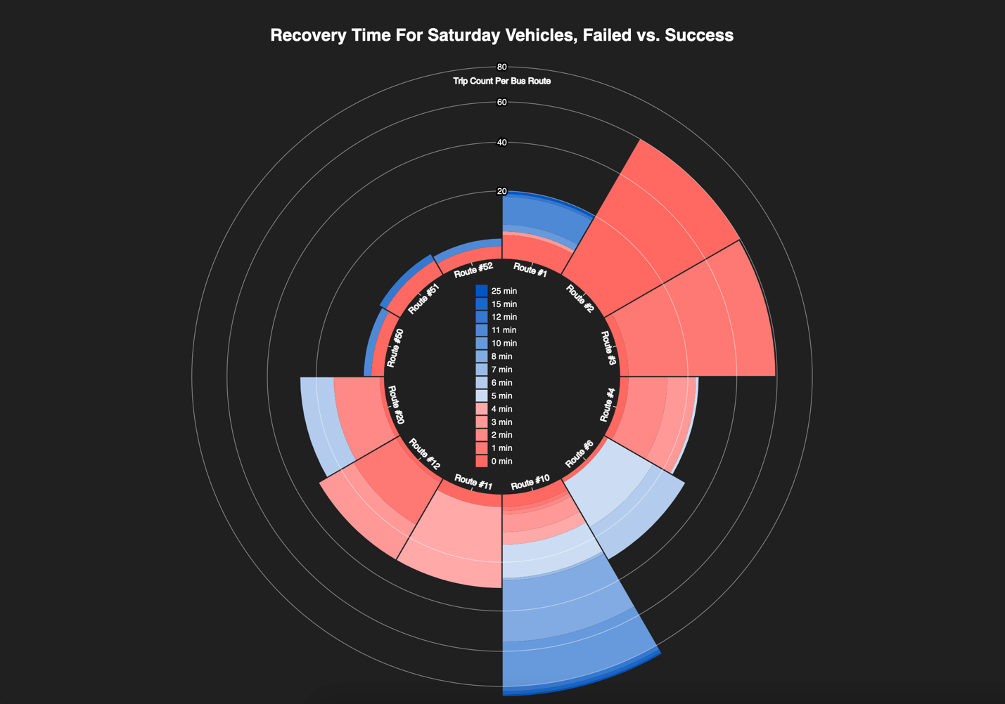

Figure 12 - The recovery time for Saturday vehicles graph

The second graph on the Charging Results page shows the energy consumption of both depot charging and opportunity charging results, as they are the same. When hover over the

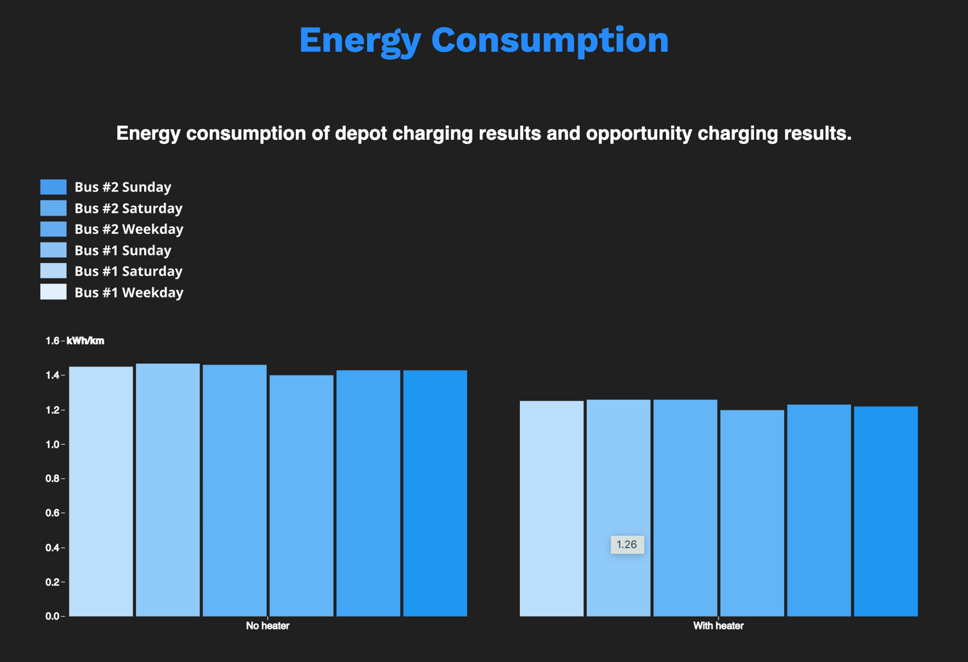

Figure 13 - The energy consumption graph

## 4. GHG Emission Analysis

On this page, the viewer will find graphs that visualizes the GHG emission analysis for both diesel bus and electric bus.

The first graph is a comparison chart of 2019 total GHG Emissions by diesel buses vs. BEBs. It is animated to show how the GHG emissions accumulated monthly in 2019. The red bars represent diesel bus verses the blue bars represent BEBs, with the bus model name attached at the right end of each bar. The month is shown at the bottom right. When the animation ends, it shows how the total GHG emissions generated in 2019 by all the buses.

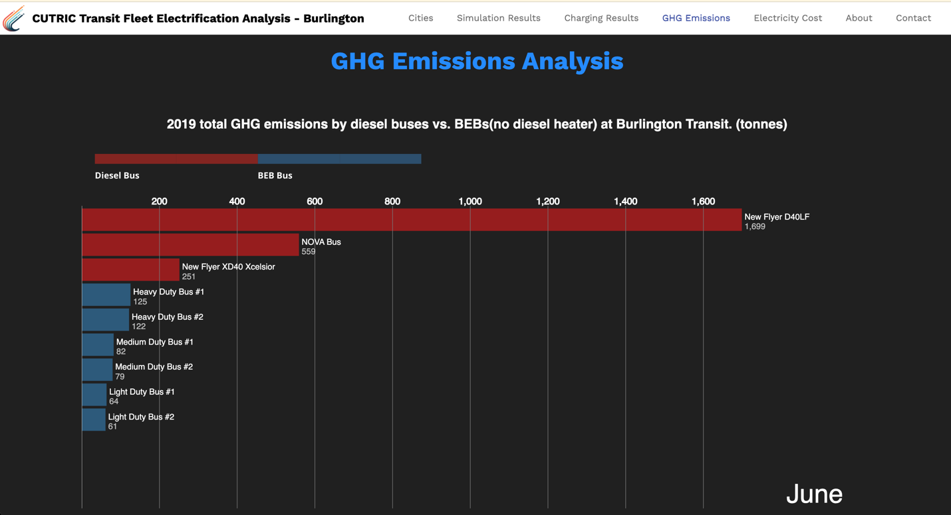

Figure 14 - A comparison chart of 2019 total GHG Emissions by diesel buses vs. BEBs

The second graph is a line chart displaying 2019 diesel usage by diesel buses at Burlington Transit. The data was extracted from the Table 14 in the Burlington report.

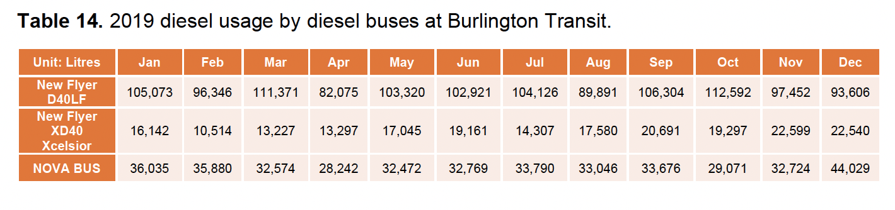

Figure 15 - Table 14 in the Burlington report

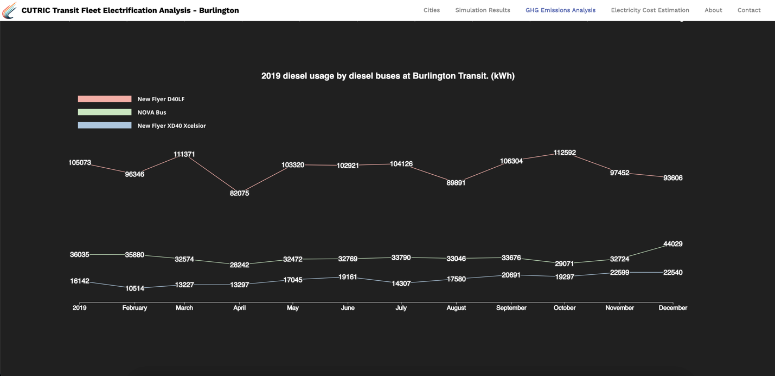

Figure 16 - 2019 Diesel usage by diesel buses at Burlington Transit

The third graph is a grouped bar chart displaying annual GHG emissions from electricity, based on Table 15 in the Burlington report.

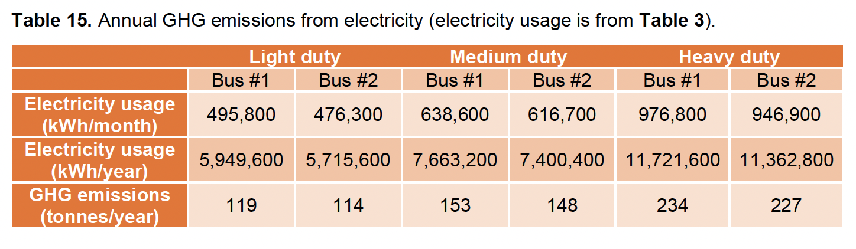

Figure 17 - Table 15 in the Burlington report

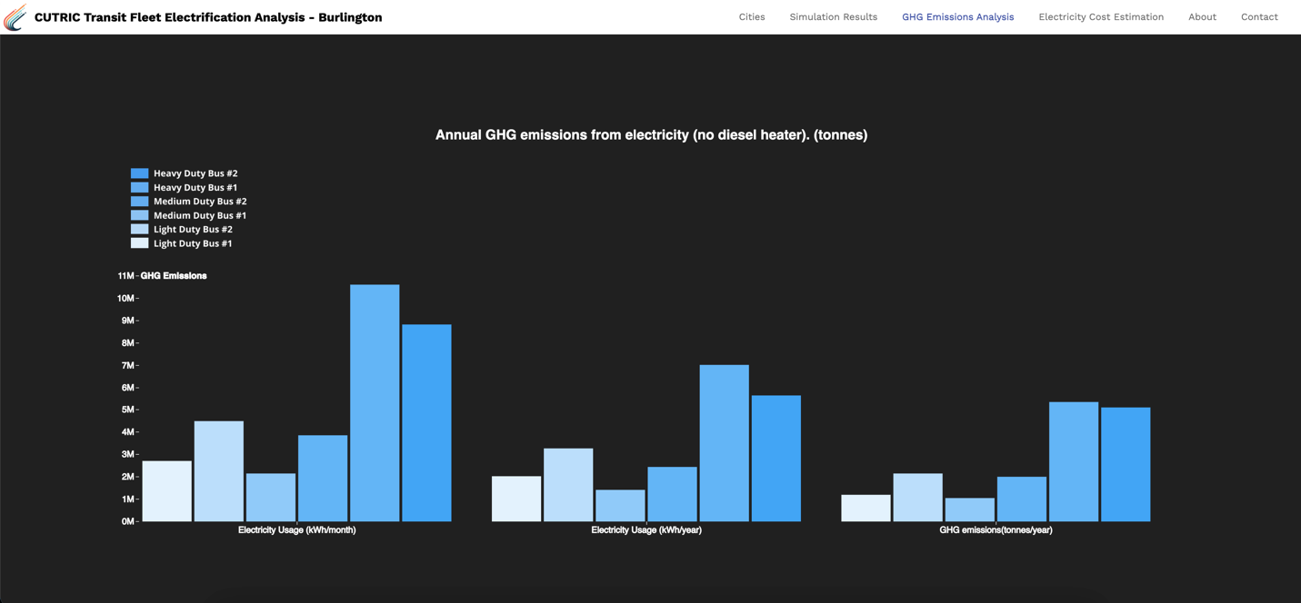

Figure 18 - Annual GHG emissions from electricity

## 5. Electricity Cost Estimation

On the Electricity Cost Estimation page, the viewer will find graphs that visualizes electricity cost estimation for both diesel bus and electric bus.

The bar chart on display is based on Table 28 from the Burlington report.

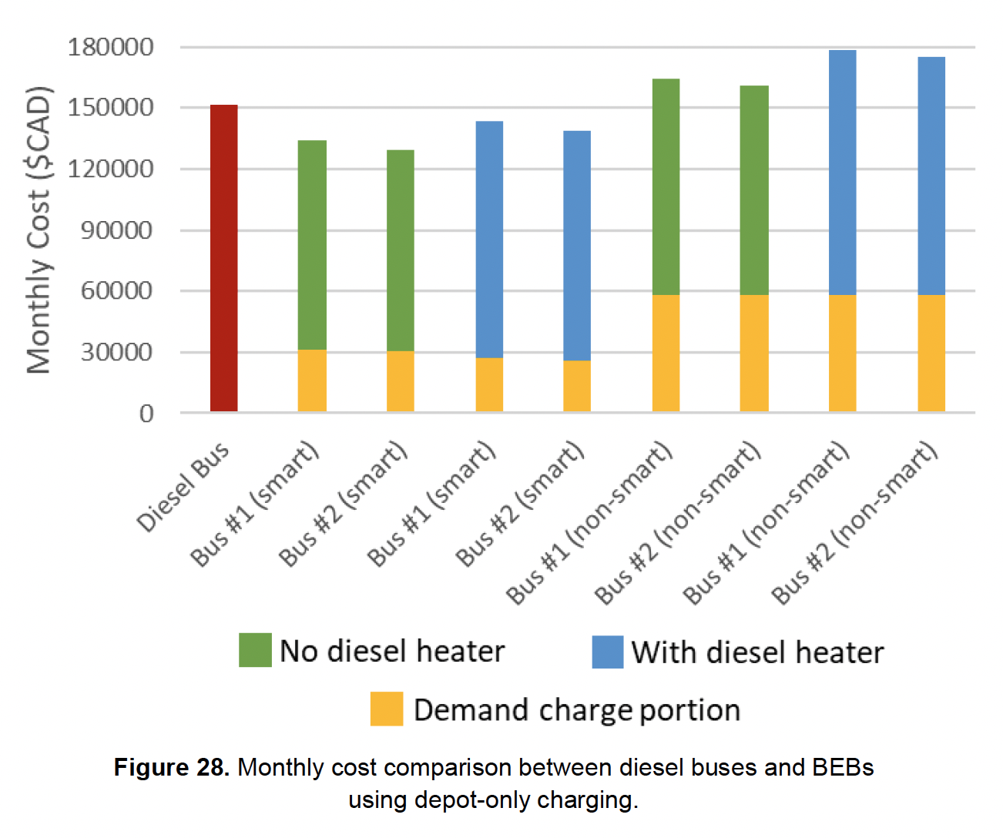

Figure 19 - Figure 28 from the Burlington report

We developed a set of icons to represent the electric bus vs. diesel bus, smart bus vs. non-smart bus, with diesel heather vs. no diesel heater, bus #1 vs. bus #2. When hover over each bar, more details will be displayed on a tooltip.

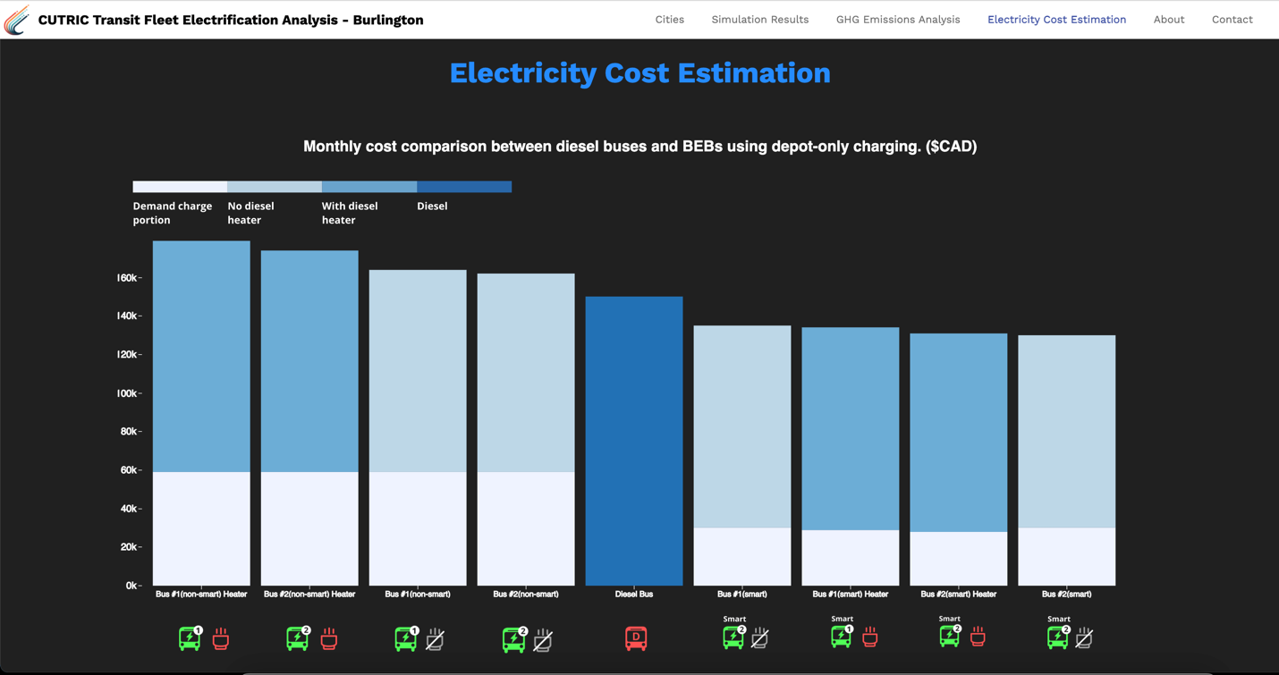

Figure 20 - Monthly cost comparison between diesel buses and BEBs

## 6. About

The about page will contain any information CUTRIC would like to show related to the transit analysis. For the prototype, we borrowed some copy and one group photo from CUTRIC’s website, to indicate how this page can be potentially used.

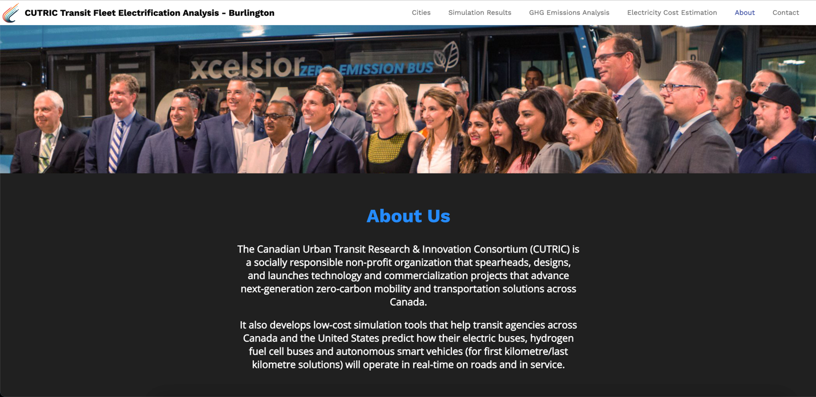

Figure 21 - The About page

## 7. Contact Us

The viewer will be able to find all the contact information on the Contact Us page. The Email Us button can be customized to redirect to any email address. Again, we borrowed some language and image from the CUTRIC website, as well as the office & mailing address and email address.

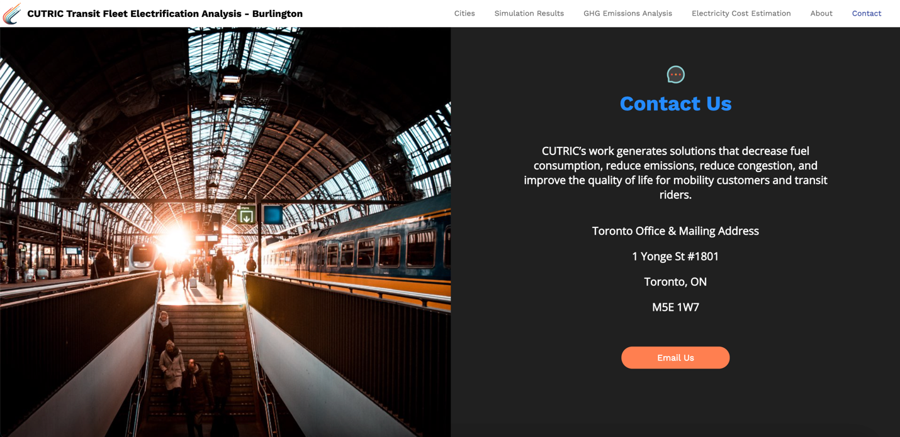

Figure 22 - The Contact page

# Code Components

## Mapbox

## D3.JS

### Graphs hosted on Observable

Most graphs displayed in the prototype are embedded through JavaScript runtime from Observable.

